Step 1: Having the Conversation:
Start by watching This Video:
Having the LTC Conversation
Then ask your clients these 2 questions
- You may never need long term care, but if you did, how would that affect your family?
  - Your Spouse
  - Your Children
  - Your Finances
- If You needed care, how are you going to pay for it?

Check out our Interactive Consumer Website:
This interactive landing page can help you navigate the LTC conversation during your interaction, or act as a pre/post meeting tool your clients can work through at their leisure. We can also customize this landing page with all your contact info and headshot. All you have to do is ask!

“There’s a 70% chance, once you turn 65, that you will need some form of long-term care. We need to setup a plan to protect against that. Let’s protect your family and your nest egg.”

Step 2: Designing the Policy:
Finding the right solution starting begins with the LTC Client Profile Fact Finder

Fact Finder
Client Information:
Client Name: _______________ Client Name: ______________
Gender: _____________________ Gender: ___________________
Age: _________________________ Age: _______________________
Financial information
Employment Income: $_____________________
Social security income: $____________________
Pension(s) income: $_______________________
Other income: $___________________________
Qualified funds: $__________________________
Non-qualified: $___________________________
Stocks & bonds: $_________________________
Life Insurance Policies Total Cash Value: $_____
NQ Annuities - List individually if more than One:
Annuity 1 Value: $______________ How much is gain: $_____________
Annuity 2 Value: $______________ How much is gain: $_____________
Annuity 3 Value: $______________ How much is gain: $_____________
Annuity 4 Value: $______________ How much is gain: $_____________
Traditional LTC Policy information:
Name or Carrier: __________________________________
Date purchased: ___________
Rate increases? ___________ % increase________
Benefits Info:
Daily/Monthly Benefit: $__________ Day/Month
Benefit Period: _________________ Days/Months/Years
Total Lifetime Benefit/Pool of Money: $______________
Inflation Protection: _______________

Step 3: Designing the Right Solution/Getting a Quote:
- Access our rate Calculator: Click Here to use our easy rate calculator
- Call: (BGA Name, Contact Name & Phone # to illustration contact)
- Call or email: Lucas Pelfrey, 844-658-3621, LucasPelfrey.isp@oneamerica.com
- Reference our Summary of Care Solutions Products as an overview to the funding options by product and target marketing age range

Step 4: Explain the solution:
Brief Asset Care Funding Videos:
*All states other than CA

Single Premium Recurring Premium Using Qualified $$
Asset Care Single Premium Asset Care Re-occurring Prem Using Qualified $$

Asset Care with ROP

Consumer PowerPoint and Product Guide for AssetCare:
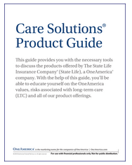
Click to view and download digital PDF:

Sales Ideas and Consumer PowerPoint for Annuity Care:
Annuity Care Portfolio Training - Recorded Webinar
Pension Protection Act FAQ
Annuity Review: Is Your Clients Annuity Where it Needs to be?
Indexed Annuity Care Sales Idea: Lifetime Leverage Sales

Step 5: Explaining the Illustration:

Understanding the OneAmerica Illustration

Step 6: (Optional) Check their Insurability: Using our PUI form (after completion submit this to cspui.ind@oneamerica.com)

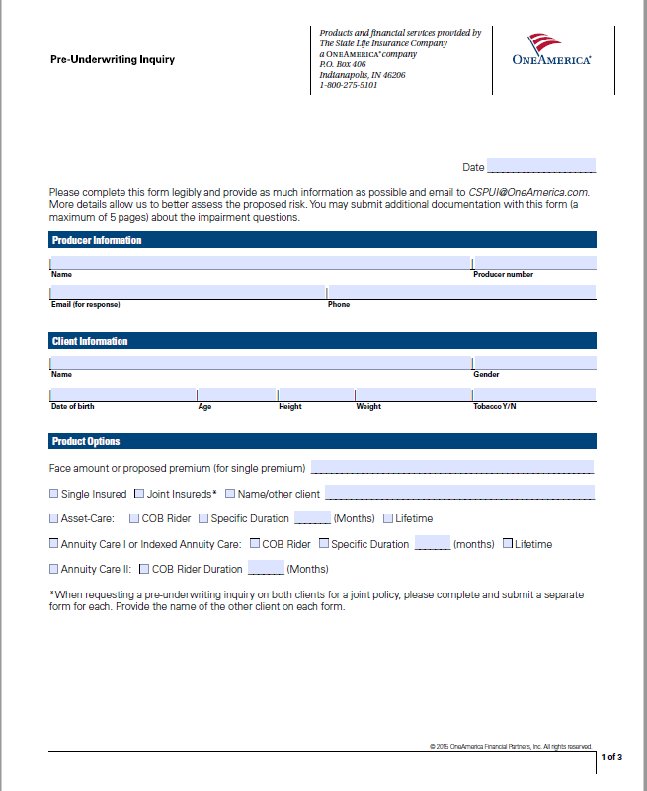

Step 7: Write the application:
- Access our e-Application: Click Here to Access our E- Application
- Check out our e-app resources: eApp Tip Sheet (I-28398) and eApp Prep Sheet (I-33916)
- Call: (BGA Name, Contact Name & Phone # to illustration contact)
- Call or email: Lucas Pelfrey, 844-658-3621, LucasPelfrey.isp@oneamerica.com
Resources
OneAmerica Financials:
C-26066 About OneAmerica Flyer
C-26169 About State Life Flyer
C-26210 Financial Ratings Flyer

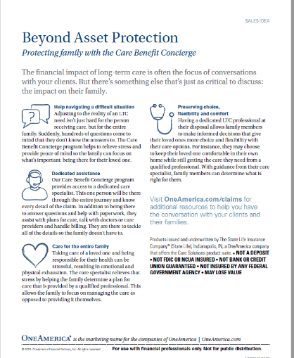
Claims Concierge Resources:

Ineligible Conditions and Health Questions:
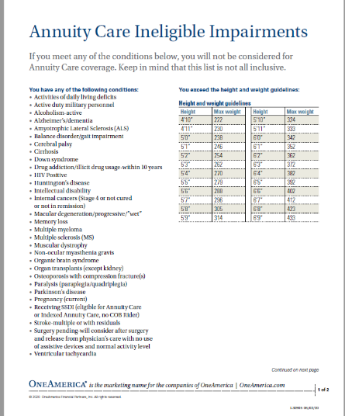
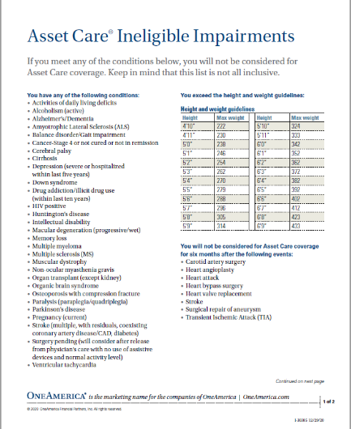
Asset Care Annuity Care UW Guide:
